**CC Assignment 2**

**Neeti Kurulkar**

**Install and Configure Google App Engine**

1. **Install Google Cloud SDK and Sign In**

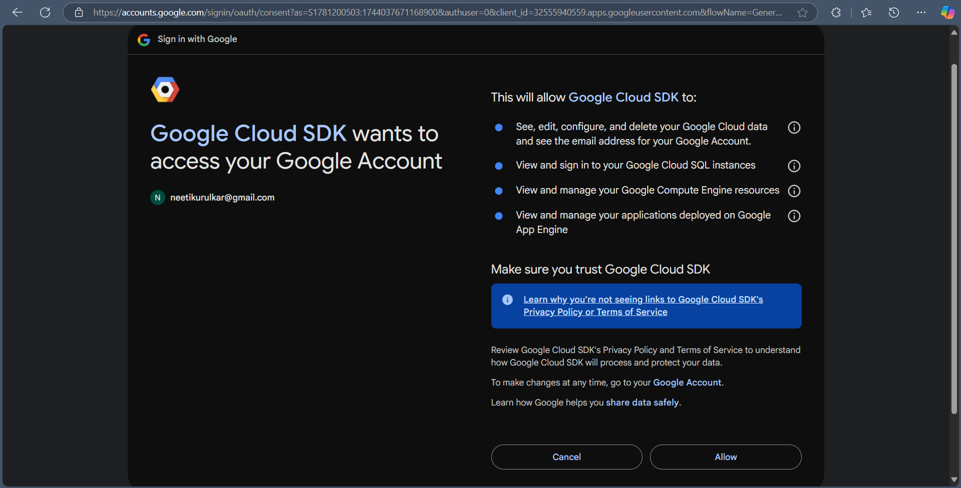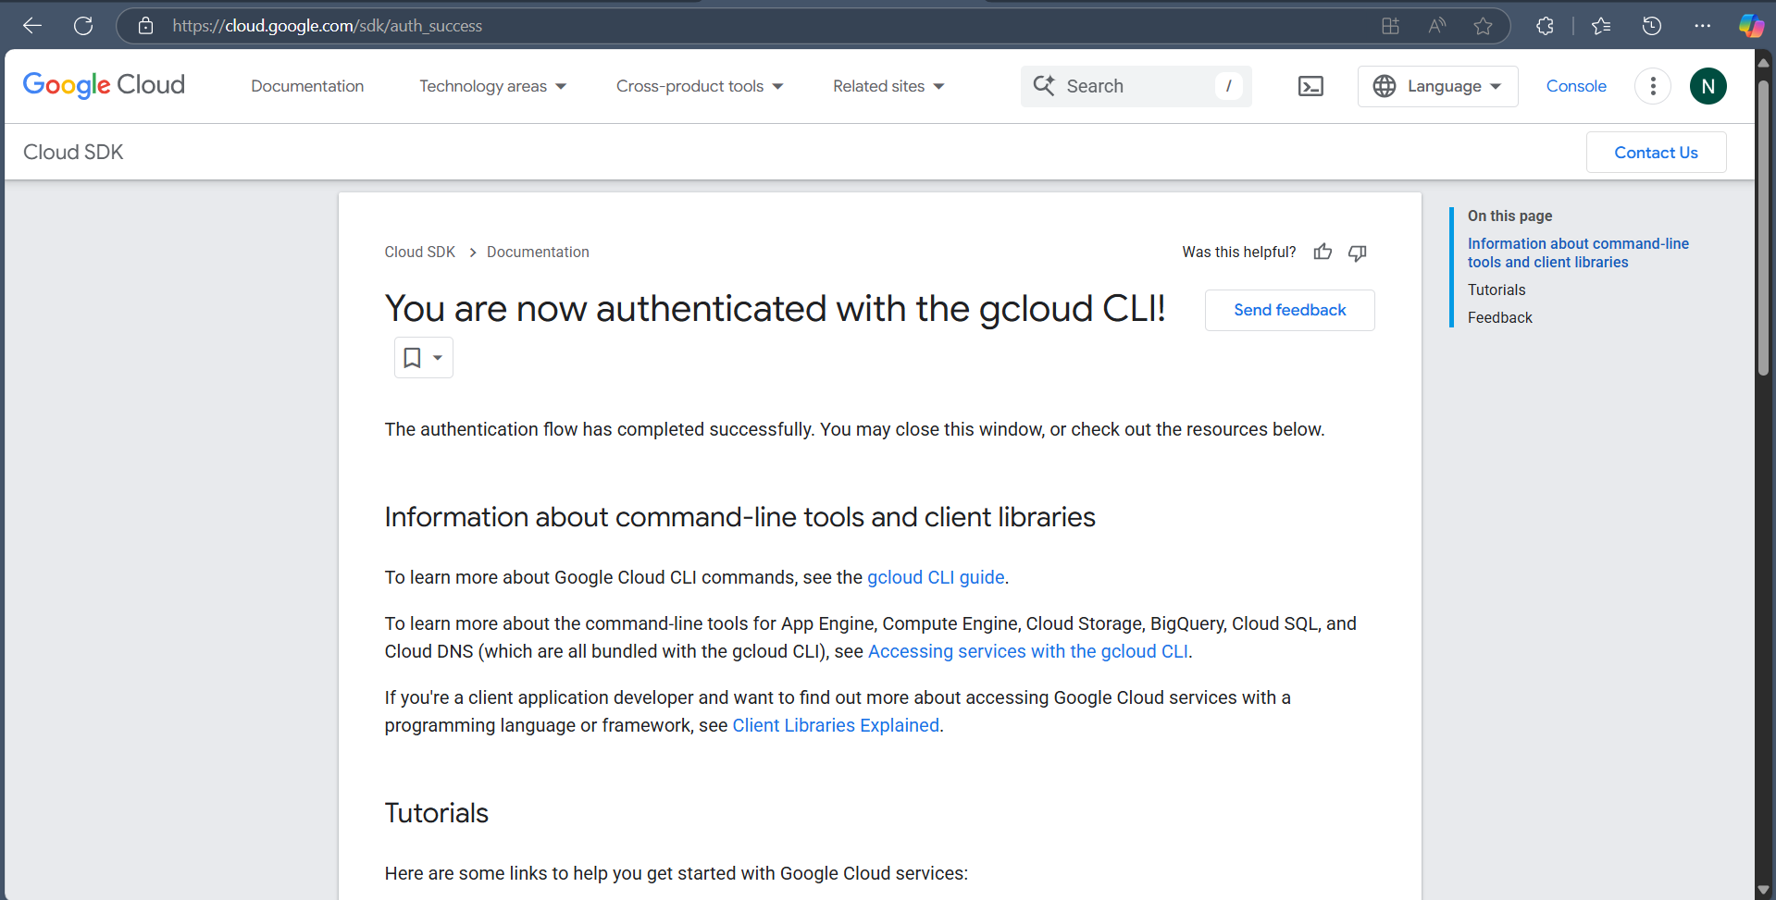

1. **Install Google App Engine using Google Cloud CLI**

1. **Create new project in Google Cloud Console**

1. **Codes:**
   1. **App.yaml**

**runtime: python39**

**handlers:**

**- url: /.\***

**script: auto**

* 1. **Main.py**

**from flask import Flask**

**app = Flask(__name__)**

**@app.route('/')**

**def hello():**

**return "Hello, App Engine!"**

* 1. **Requirements.txt**

**Flask==2.3.2**

1. **Deploy app**

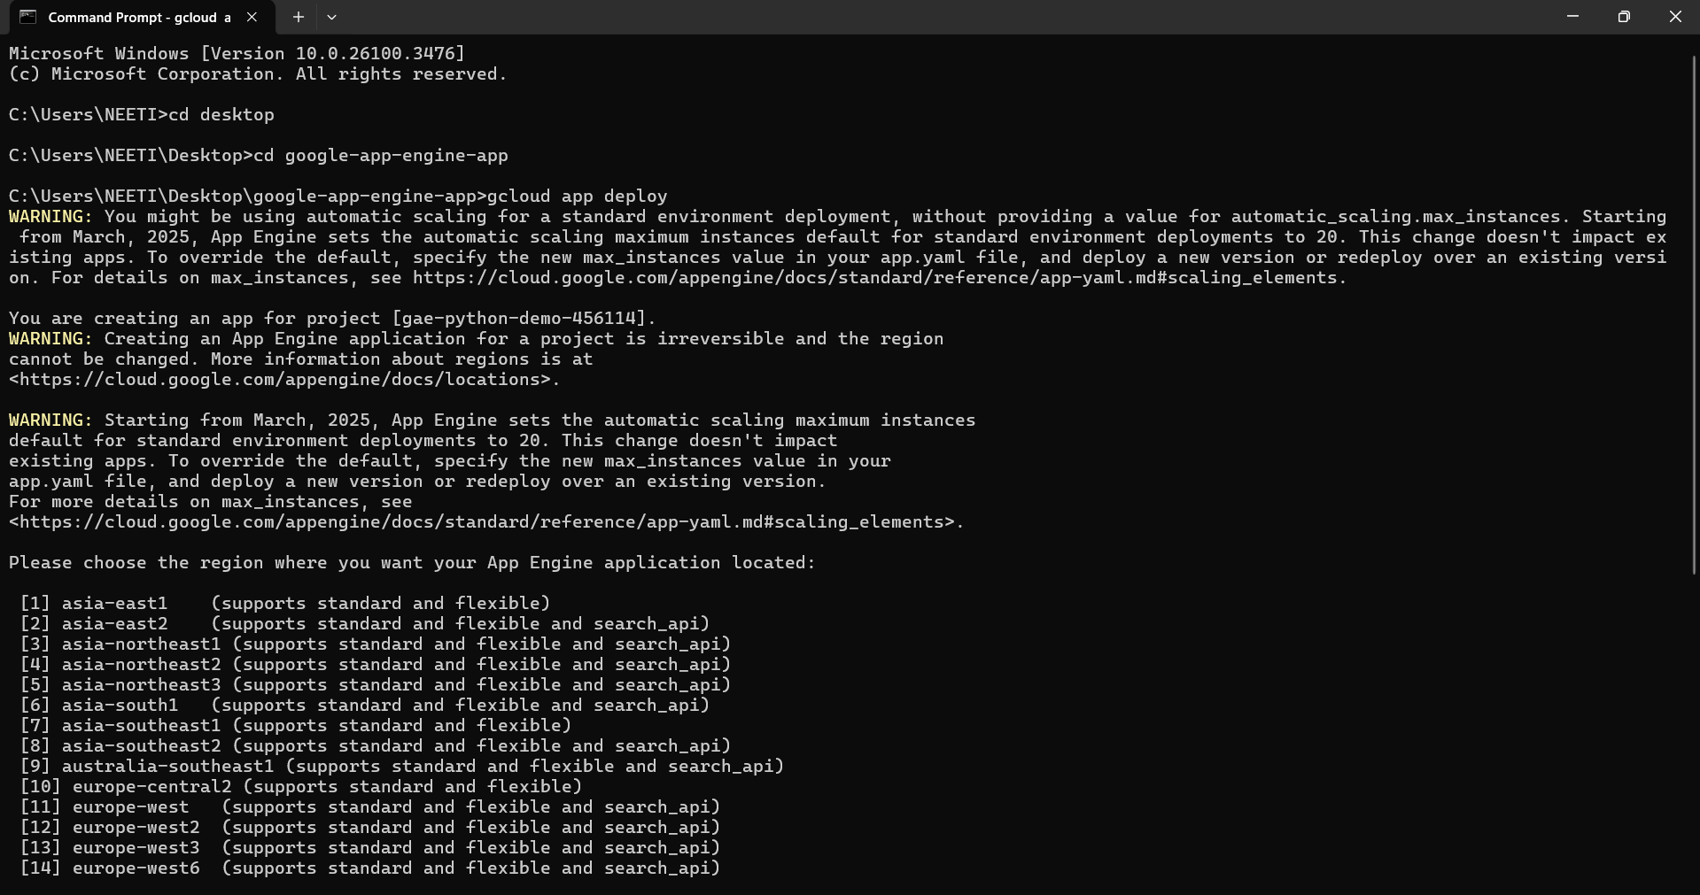

**Output:**

